Krithika Kannan

CS 2336.501

Homework 5

10/11/2020

UML Diagrams for Homework 5

Q9_1:

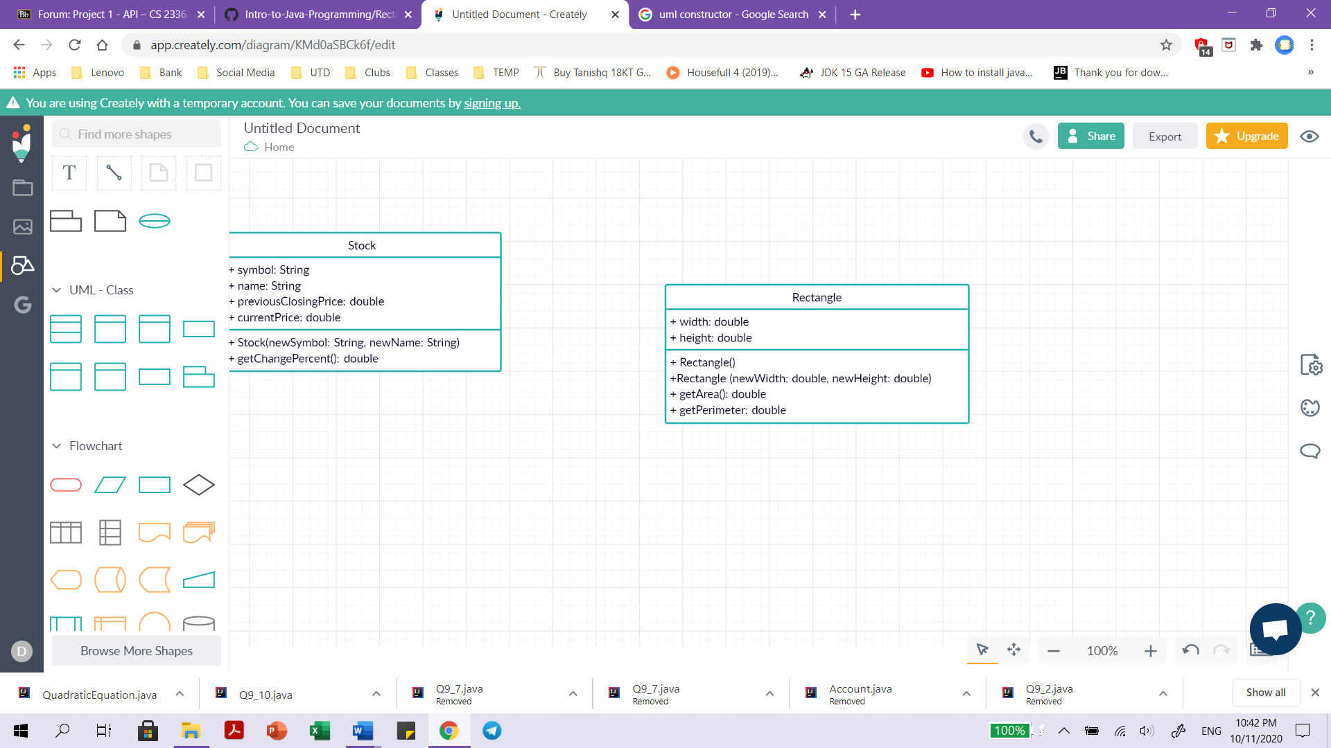

Q9_2:

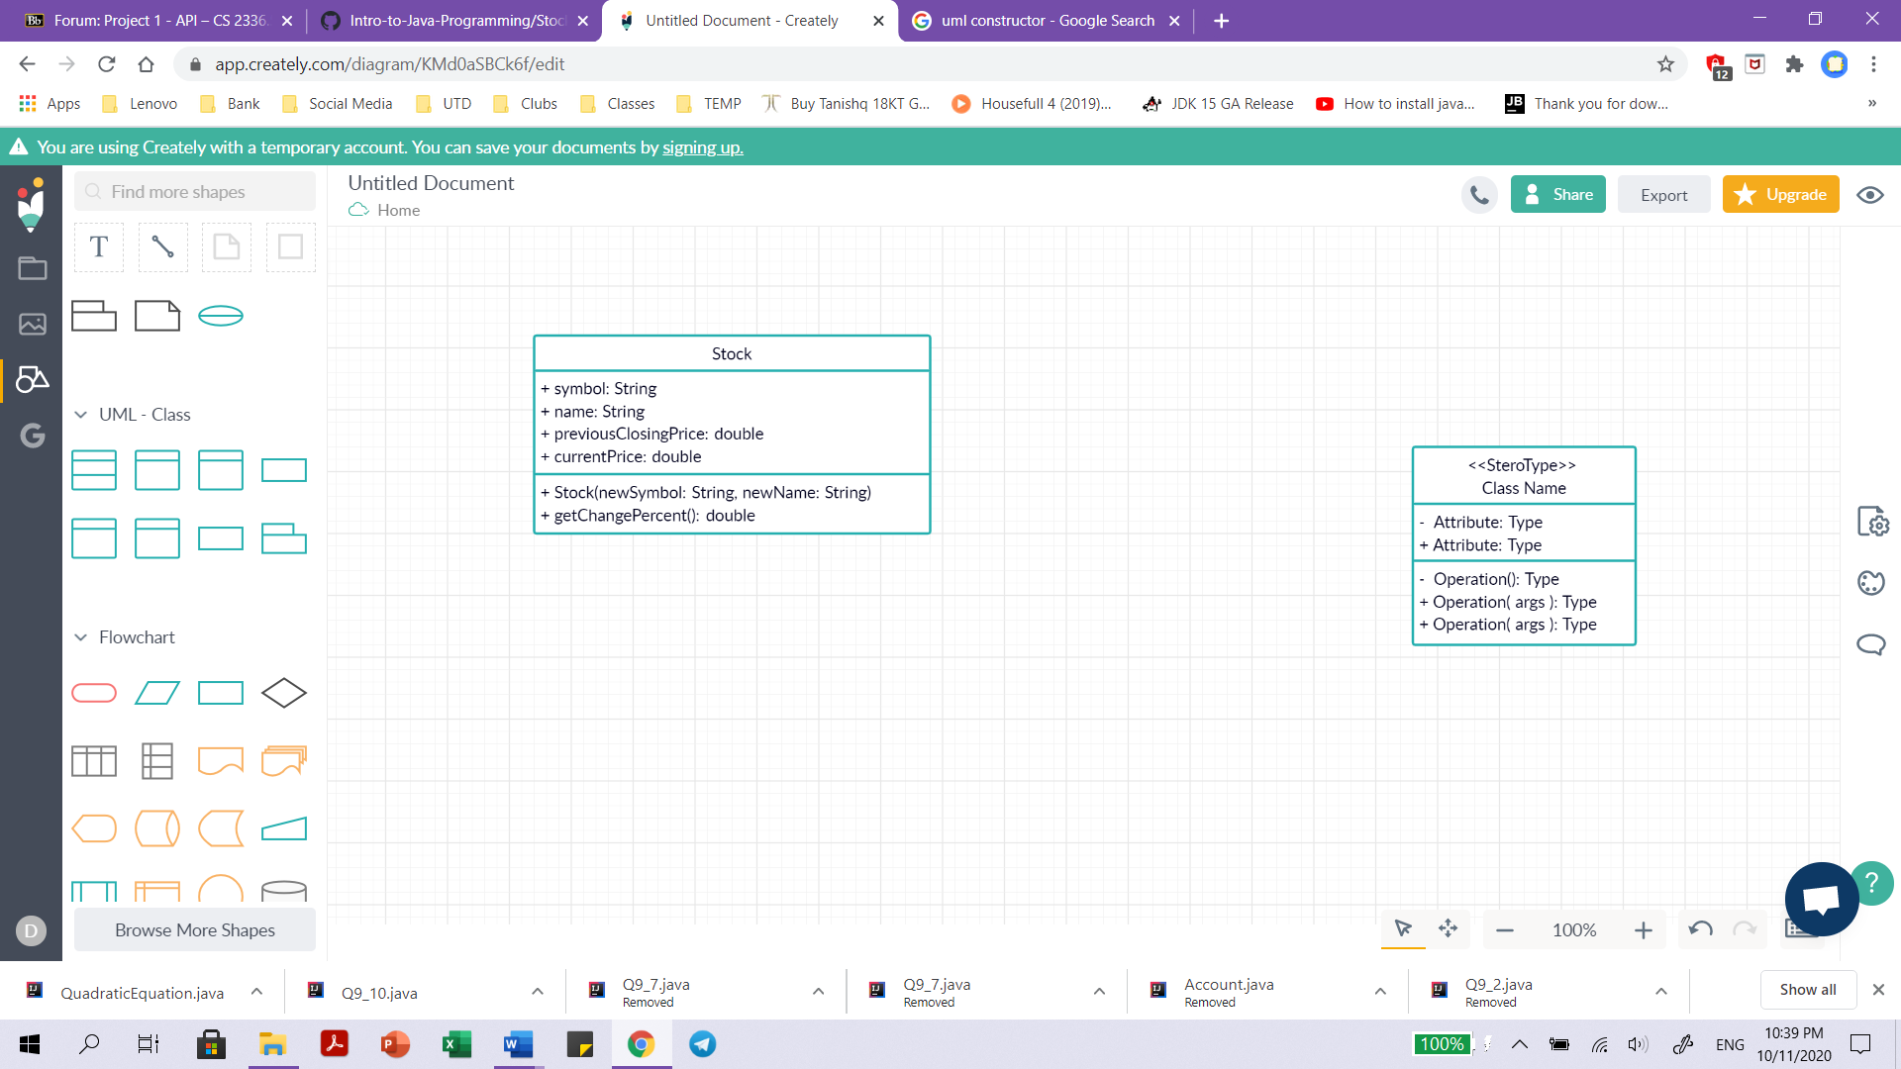

Q9_7:

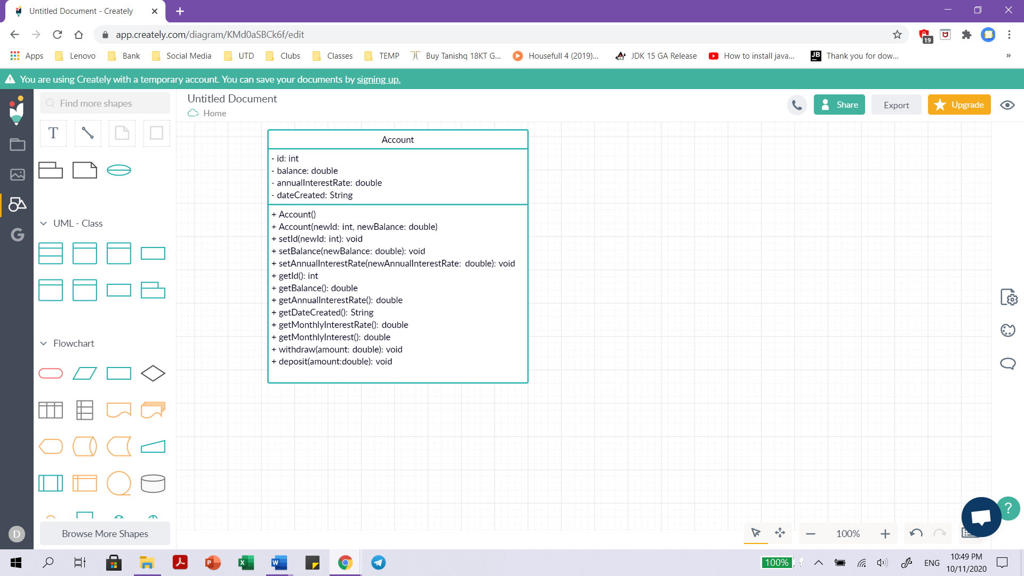

Q9_10:

